TITLE (CALIBRI, 14 PT, CAPITAL LETTERS, BOLD, CENTERED PARAGRAPH, SINGLE SPACE)

A.B. Authorª, C.D. Author^{b}
(Calibri, 11 pt, bold letters, single space, centered paragraph, underline the name of the presenting author)

ª Affiliations of the author, complete postal address and e-mail.
^{b} Affiliations of the co-author, when different, complete postal address (Calibri, 11 pt, italic letters, single space).

Main message: Write down the main message of your contribution (maximum 500 characters with spaces, Calibri, 11 pt, single space, justified paragraph, 2.5 cm left and right margins).
(All titles as Main message, Keywords, Introduction, Experimental, Results and Discussion, should be written using Calibri, 11 pt, single space, bold.)

Keywords: Enter comma separated keywords (maximum 5) here.

Introduction
Briefly describe the background and the significance of the research (maximum 500 characters with spaces, Calibri, 11 pt, single space, justified paragraph, 2.5 cm left and right margin).

Experimental
Give a short summary on the methods applied (Calibri, 11 pt, single space, justified paragraph, 2.5 cm left and right margin).

Results and Discussion
Combine results and discussion (Calibri, 11 pt, single space, justified paragraph, 2.5 cm left and right margins). The total length of the abstract should be maximum 2 A4 pages including no more than one figure and /or one table and up
to 5 references.

New paragraph starts after a line spacing. References should be numbered in the order of appearance in the text with Arabic numerals in brackets [1,2]. Styles for figure captions and tables are given below. Insert the Figure as image file (tiff, jpg, etc.) with appropriate resolution. The figure legend, as well as other notations e.g. “a” and “b”, should be the part of the image file.

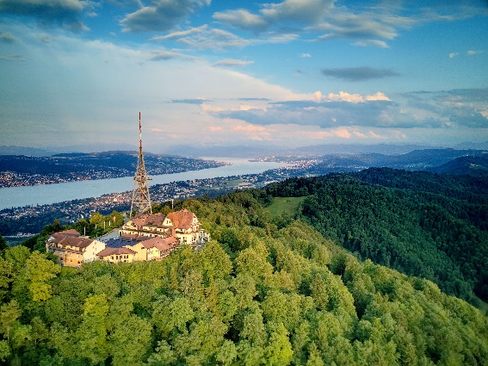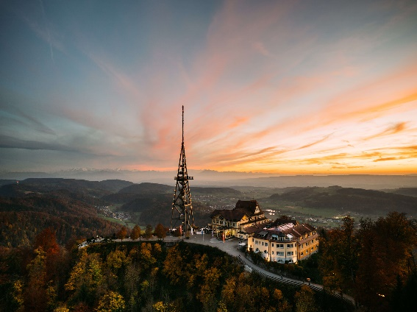

FIGURE 1. Drone pictures of the UTO Kulm on top of Uetliberg, where the FRPM23 gala dinner will take place

TABLE 1. Selected properties of flame retarded polymeric samples

Sample | Property 1  [unit] | Property 2  [unit] | Property 3  [unit] | Property 4  [unit]
AB | 56 | 92 | 3521 | 17.9
CD | 43 | 123 | 2951 | 19.1
BD | 79 | 126 | 2551 | 19.7
DE | 81 | 182 | 2200 | 21.3

Acknowledgement: Acknowledge your funding grant here.

References (not more than five): Please use referencing style of Polymer Degradation and Stability (Elsivier) as shown below.

1. Coskun M, Demirelli K. Thermal degradation of sulphonylated polystrene. Polym Degrad Stab 1996;51(2):173-178.
2. Andrade JD, editor. Polymer surface dynamics. New York: Plenum Press, 1988.
3. Ratner BD, Yoon SC, Kaul A, Rahman R. In: Planck H, Syre I, Dauner M, Egbers G, editors. Progress in biomedical engineering, Vol. 3: Polyurethanes in biomedical engineering II. Amsterdam: Elsevier, 1987. p. 213.
4. Tai D, Terazawa M, Chen CL, Kirk TK. Proceedings International Symposium Wood Pulping Chemistry 1983;4:144-149.

- Please tick the type of presentation your abstract should be considered for (only select one of the following options)
☐ Poster only
☐ Oral only
☐ Poster or oral

- Please tick the topics in which your presentation fits best
☐ Sustainability in Flame Retardant Materials (FRs in European Green Deal)
☐ New Developments in Flame Retardants (chemistry, application, synergism)
☐ Investigating Flame Retardant Mechanisms
☐ New Developments in Flame Retardant Coatings and Textiles (emphasis on transportation, architectural and protective textiles)
☐ Flame Retardants and the Environment
☐ Recycling of Flame Retardant Materials
☐ Testing, Characterization and Modelling of Flame Retardant Materials
☐ Fire safety requirements and standardization of products used for EVs (batteries, e-powertrain, charging stations)
☐ Flame Retardant Innovations in emerging markets such as e-mobility, composites,
additive manufacturing and 5G telecommunication

- If you are a student or an early stage researcher (PhD, master or bachelor with maximum 2 years of working experience) you can apply for a travel grant. To be considered for the grant you need to submit a CV and a motivation letter (max. 500 words) with the abstract. Please tick the box to be considered for the travel grant.
☐ Application for travel grant

